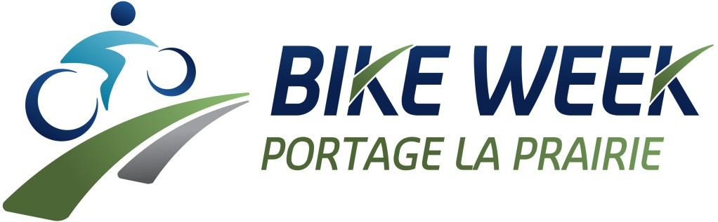

May 25th- May 31st, 2024
See our Facebook Page for more information: Portage Active Transportation Committee

Saturday  May 25  GRAVEL  GRUMBLE  WITH JUNK YARD DOGS  Lavenham Hills  10:00 am  Register by May 22nd  (Blair 204-856- 9352)  *Helmet  Mandatory  *25 km moderate  or 30 km difficult | Sunday  May 26  YOGA IN  THE PARK  WITH BREEZE YOGA  Duck Pond  1:00 pm  Ride your bike to Island Park and then do some Yoga! Bring your own mat! | Monday  May 27  ICE CREAM RIDE  1:30 pm  Meet at Splash Island parking lot  *Gentle pace | Wednesday  May 29  COOKIE RIDE  6:00 pm – 8:00 pm  Pit Stops – ECVS, FLR, YQS, LVS & Island Park  *Prize entries for groups visiting all 5 pit stops  *Thank you to Girl Guides for baking cookies, ingredients by CFPD, grapes provided by CPCS, and Ice cream courtesy of City Youth Councilor | Thursday  May 30  GRUB CRAWL  5:30 pm  Meet at Splash Island Parking lot  Tickets $30 includes meal, drink & tip  *Registration required  *Check Facebook and Instagram for payment and menu | Friday  May 31  LADIES’ SUNRISE RIDE  6:30 am  Meet at Red River College front parking lot  *Coffee to start at 6am  *Ride to start at 6:30am
 |  | JYD TRAIL RIDE  7:00 pm  Meet at Dump Hill  *Helmet and off road bike mandatory |  |  | BIKE TO SCHOOL  *Information provided by schools
Helmets mandatory for 17 & under – Helmets encouraged for adults
*Check Facebook for cancellations*

